Remote Help with Microsoft Intune – Support Team Guide
Purpose
Remote Help is designed to enable support personnel to securely assist users by remotely viewing or controlling their devices. The solution integrates seamlessly with Microsoft Intune, ensuring compliance and supporting role-based access. Both User and Helper device must be Intune managed in the same Tenant. Cloud PC will be assigned as a jump box for support team.

Initiating a Remote Help Session
*Option 1: Via Intune Admin Center*
- Navigate to Devices > All Devices > Select Device
- Click “New Remote Assistance Session” and select Remote Help
- Share the session code with the end user
- User receives a notification and opens Remote Help
*Option 2: Via Remote Help Application*
- Open the Remote Help app and sign in
- Under “Give Help” select “Get a security Code”
- Share the generated security code with user
- User’s Remote Help app, under Get Help, have user enter security code and submit.
Session Activities
*Helper Capabilities:*
- View user's screen or assume full control (requires user consent)
- Use elevation permissions to perform administrative tasks
- Utilize integrated chat functionality
- End session at any time
*User Controls:*
- Accept or decline session requests
- Select between screen sharing or granting full control
- Terminate session as needed

Toolbar Buttons (Left to Right)
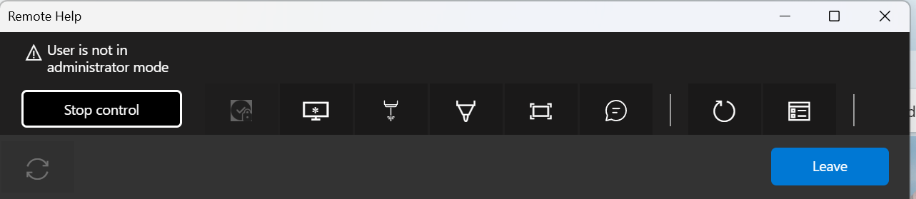
- Top Bar
  - Title: Remote Help
  - A warning message: “User is not in administrator mode”
This indicates that the remote user does not have elevated privileges (admin rights). As a result, certain actions requiring admin permission (like installing software or changing system settings) cannot be performed remotely.
- Main Controls
  - Stop control button: This is prominently displayed, meaning the helper currently has control of remote machine and can stop session at any time.
- Toolbar Icons
  - The toolbar contains several icons (from left to right):
    - Admin Session: Will allow UAC prompt to be visible.
    - Screen control icon: Indicates screen sharing or control.
    - Laser pointer icon: Used to highlight areas on the remote screen.
    - Annotation icon: For drawing or marking on the screen.
    - Chat icon: Opens a chat window for communication.
    - Restart icon: For rebooting the remote machine.
    - Session info icon: Displays session details.
- Bottom Right
  - Leave button: Ends the remote help session.

